Muhammad Naimatullah Khan 21K-4540

QUESTION NO 1:

TITLE My First Program (Text.asm)

INCLUDE irvine32.inc

.DATA

source BYTE "HELLO WORLD ",0

newArray BYTE LENGTHOF source DUP(0)

.CODE

main PROC

mov ecx, LENGTHOF source

L1:

mov al,source[ecx-1] ; saving the last charactr of array (d)

mov newArray[ecx-1],al ; copying the last charactr of array in new Array(d)

LOOP L1

mov edx, offset newArray ; string print krwane k lie edx m save krna ha

call writestring

exit

main ENDP

END main

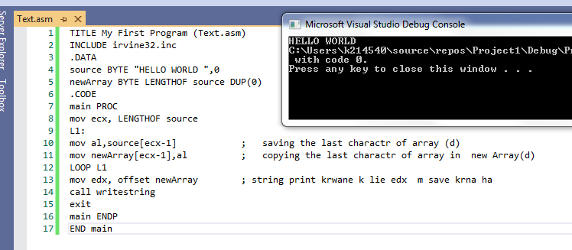

QUESTION NO 2:

TITLE My First Program (Text.asm)

INCLUDE irvine32.inc

.DATA

newArray WORD 10h,20h,30h,40h,50h

.CODE

main PROC

mov eax,0 ; storing first index in it

mov ebx, LENGTHOF newArray-1 ; isme last index save ha

mov ecx, LENGTHOF newArray/2 ; isme size of array ha

L1:

mov dx, newArray[eax \* TYPE newArray] ; dx m array ka first element save kraya ha

xchg newArray[ebx \* TYPE newArray],dx ; array ka 1st element ko array k last index sa exchange kia ha

mov newArray[eax \* TYPE newArray],dx ; then exchange hui wi value ko dx m save kralia ha

inc eax; ; increamenting first index

dec ebx ; dereamenting last index

LOOP L1

mov esi, offset newArray ; printing the arrray method

mov ebx, TYPE newArray

mov ecx, LENGTHOF newArray

call Dumpmem

exit

main ENDP

END main

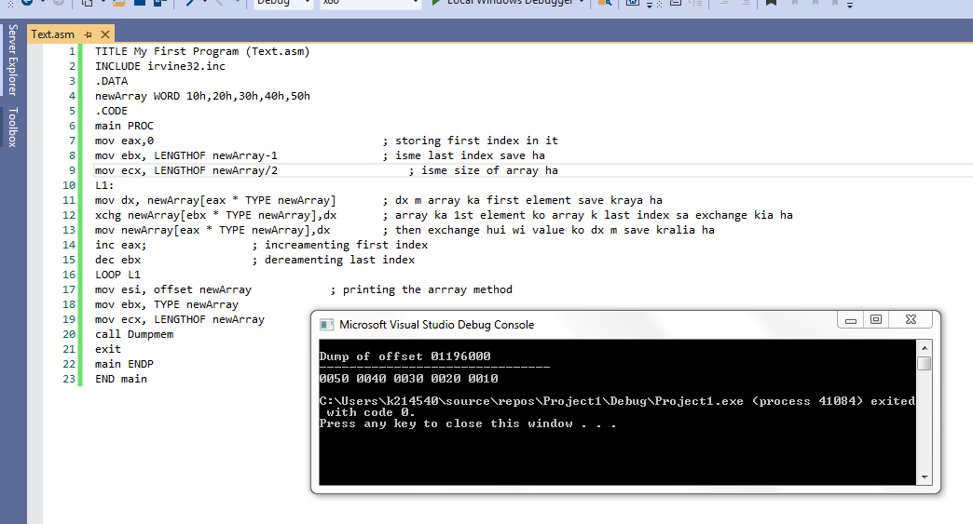

QUESTION NO 3:

TITLE My First Program (Text.asm)

INCLUDE irvine32.inc

.CODE

main PROC

mov eax,0

mov ebx,1

mov ecx,10

L1:

call writeint

mov edx,ebx

add ebx,eax

mov eax,edx

LOOP L1

exit

main ENDP

END main

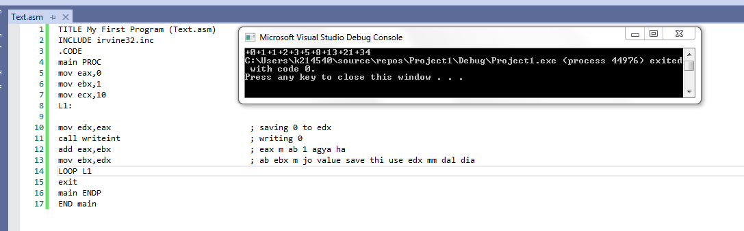

Question No 4:

TITLE My First Program (Text.asm)

INCLUDE irvine32.inc

.data

var1 DWORD ?

row DWORD 5

.CODE

main PROC

mov ecx,row

mov row,ecx

call crlf

L1:

mov var1, ecx

L2:

mov al, ' '

call writechar

LOOP L2

mov ecx, row

sub ecx,var1

inc ecx

L3:

mov al, "\*"

call writechar

LOOP L3

call crlf

mov ecx, var1

LOOP L1

exit

main ENDP

END main

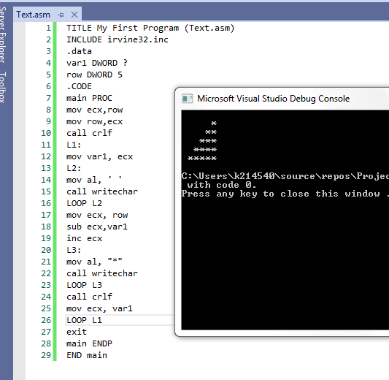

QUESTION NO 5:

TITLE My First Program (Text.asm)

INCLUDE irvine32.inc

.data

var BYTE "ENTER THE SIZE OF THE FABONACCI SERIES: ",0

.CODE

main PROC

mov edx, offset var

call writestring

call readint

mov edx,0

mov ebx,1

mov ecx, eax

L1:

mov eax,edx

call writeint

add edx,ebx

mov ebx,eax

LOOP L1

exit

main ENDP

END main

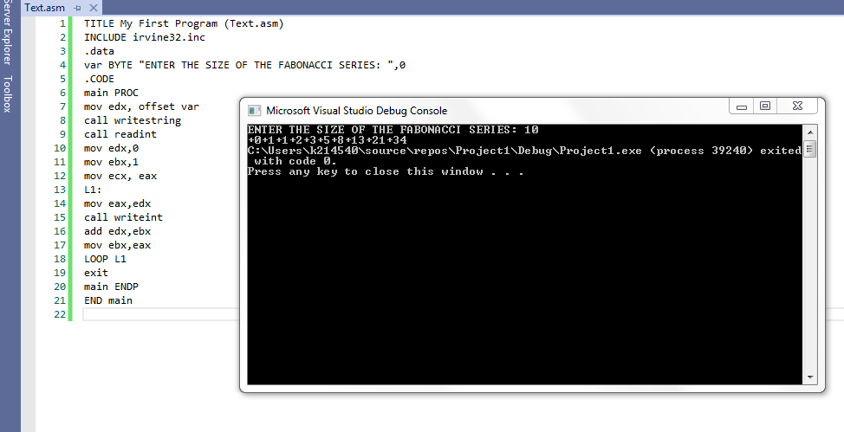

Question No 6:

TITLE My First Program (Text.asm)

INCLUDE irvine32.inc

.data

msg BYTE "ENTER THE NO OF ROWS: ",0

row DWORD ?

space DWORD ?

.CODE

main PROC

mov edx, offset msg

call writestring

call readint

mov row,eax

mov ecx,row

L1:

mov space, ecx

L2:

mov al,' '

call writechar

LOOP L2

mov ecx, row

sub ecx,space

inc ecx

L3:

mov al, "\*"

call writechar

LOOP L3

call crlf

mov ecx, space

LOOP L1

exit

main ENDP

END main

